**Câu 1:**

What is Boolean? Write down 3 different expression that results a Boolean type (i.e. 5 == 6)

**Trả lời:**

+ A Boolean value is either true or false

+ 3 different expression that results a Boolean type:

x > 3

5 != 6

x <= y

@@@@@@@@@@@@@@@@@@@@@@

**Câu 2:**

What is a flow chart? Draw flow chart for the following code snippet: (you can draw on a paper, take a picture of it)

if name == “Huy be":

print(“Hand some")

elif name == “Huy big":

even_more_handsome = True

else:

webbrowser.open(“https://www.youtube.com/watch?v=04854XqcfCY”)

**Trả lời:**

+ Flow chart: tức là sơ đồ hóa 1 chuỗi các dòng code sang dạng hình ảnh trực quan, dễ nhìn, dễ hiểu, giúp cho người sử dụng nhanh chóng hiểu rõ được sơ đồ chạy của các dòng code

+ Vẽ flow chart:

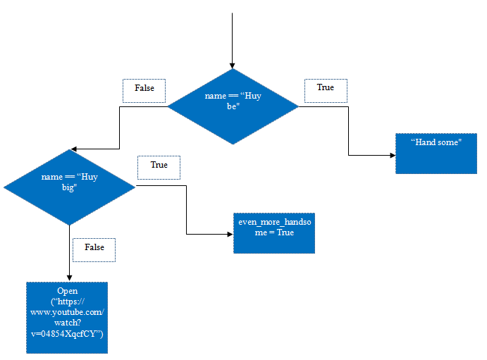

@@@@@@@@@@@@@@@@@@@@@@

**Câu 3:**

What is nested conditionals? Write a piece of code that uses nested conditionals

**Trả lời:**

File code la cau3.py

+ Nested conditionals nghĩ là 1 điều kiện lồng bên trong 1 điều kiện khác.

+ 1 đoạn code sử dụng nested conditionals:

x = int(input(“Man hinh laptop cua ban bao nhieu inch? ”))

if x >= 15:

print (“Man hinh to”)

else:

if x >= 14:

print (“Man hinh vua”)

else:

print (“Man hinh nho”)

@@@@@@@@@@@@@@@@@@@@@@

**Câu 4:**

Using turtle to draw the following shapes:

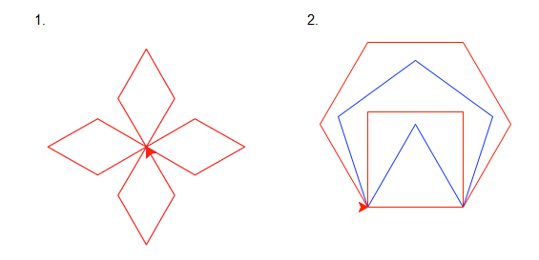

**Trả lời:**

File code là “cau4.1.py” và “cau4.2.py”

@@@@@@@@@@@@@@@@@@@@@@

**Câu 5:**

Write a program that asks user their height (cm) and weight (kg), and then calculate their BMI (Body Mass Index):

BMI = mass (kg) / (height(m) x height(m) )

Note: you must do the conversion from cm to m before calculation

Then based on the BMI, tell them that they are:

* Severely underweight if BMI < 16
* Underweight if BMI is between 16 and 18.5
* Normal if BMI is between 18.5 and 25
* Overweight if BMI is between 25 and 30
* Obese if BMI is more than 30

**Trả lời:**

File code là “cau5.py”

@@@@@@@@@@@@@@@@@@@@@@

**Câu 6:**

Write a program that asks users enter a number and then calculates factorial of n: (1 * 2 * 3 *... *n)

**Trả lời:**

File code là “cau6.py”

@@@@@@@@@@@@@@@@@@@@@@

**Câu 7:**

Study how to print without moving to a new line

Each time we call print(...) to print out something, python will automatically move to a new line, for example, the following snippet:

print("Hello")

print(",my name")

print("is B-max")

will result:

Hello

,my name

is B-max

Your task: Try to search and learn how to print without moving to new line,:

print("Hello", ...)

print(",my name", ...)

print("is B-max", ...)

# "..." is the piece of code you would add

so that the result would be

Hello,my name is B-max

**Trả lời:**

File code là “cau7.py”

@@@@@@@@@@@@@@@@@@@@@@

**Câu 8:**

Print out the following patterns, remember that the number of columns and rows can be changed later, so try to write programs that can scale

a. 40 x 1 stars (could be 20 x 1 or 50 x 1 or whatever)

* * * * * * * * * * * * * * * * * * * * * * * * * * * * * * * * * * * * * * * *

b. 40 stars and xs (could be 20 x 1 or 50 x 1 or whatever)

x * x * x * x * x * x * x * x * x * x * x * x * x * x * x * x * x * x * x * x *

You can use print(), (yes, print with nothing inside the parentheses ()) to move to new line, try it

c. 10 x 10 stars (it should also work with 20 x 30 stars or any size given to the program)

* * * * * * * * * *

* * * * * * * * * *

* * * * * * * * * *

* * * * * * * * * *

* * * * * * * * * *

* * * * * * * * * *

* * * * * * * * * *

* * * * * * * * * *

* * * * * * * * * *

* * * * * * * * * *

d. 10 x 10 stars and x’s (it should also work with 20 x 30 stars or any size given to the program)

x * x * x * x * x *

* x * x * x * x * x

x * x * x * x * x *

* x * x * x * x * x

x * x * x * x * x *

* x * x * x * x * x

x * x * x * x * x *

* x * x * x * x * x

x * x * x * x * x *

* x * x * x * x * x

**Trả lời:**

File code là từ file “cau8.1.py” đến “cau8.4.py”